Process to create credentials on for google cloud project.

1. Login to https://console.cloud.google.com/

Create new project

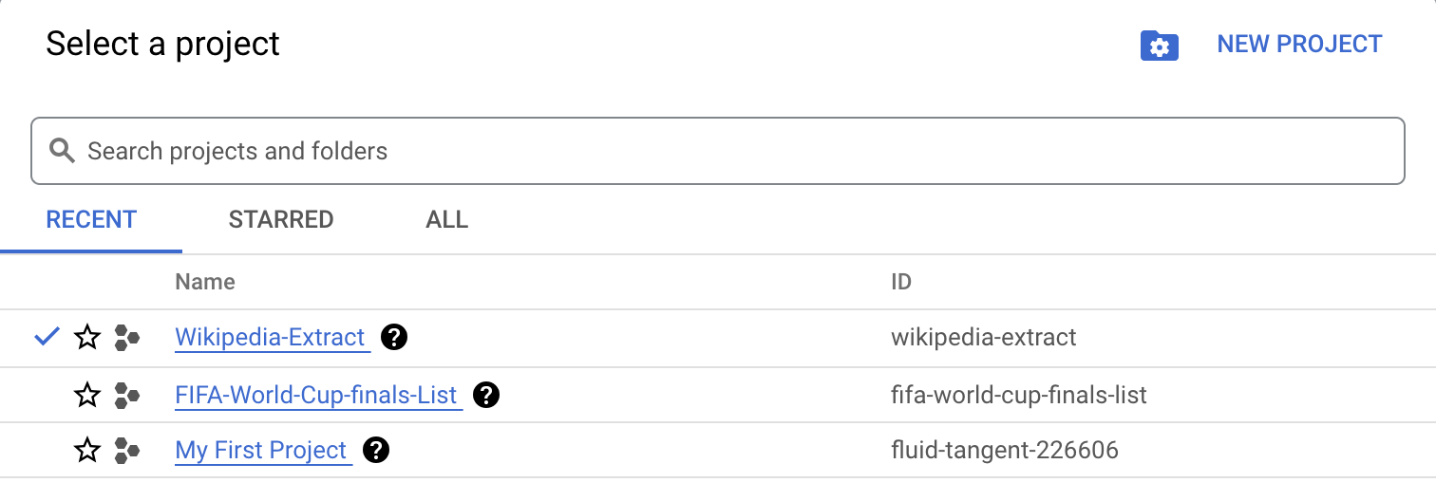

>> go to APIs & services

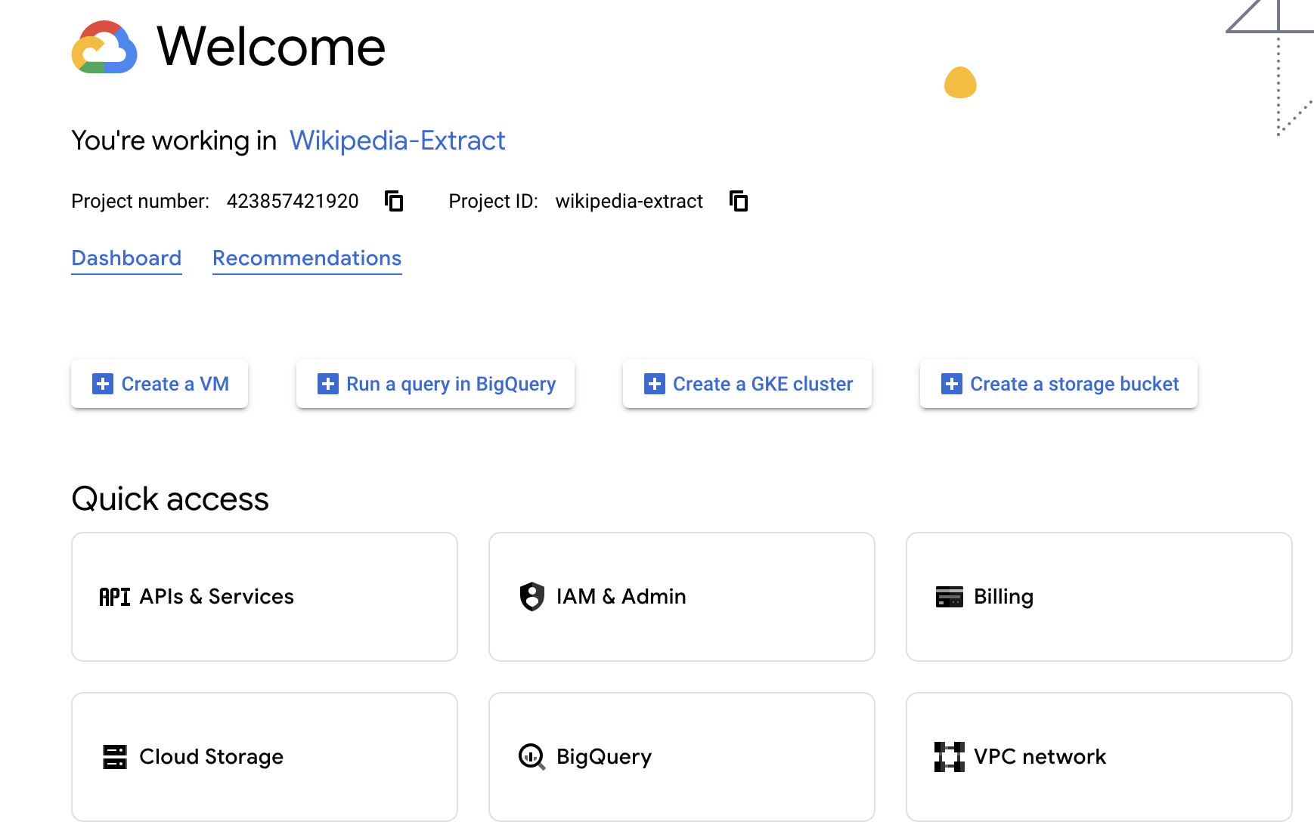

>> Select Credential & then create credentials >> service account

Note. configure consent screen if not configured.

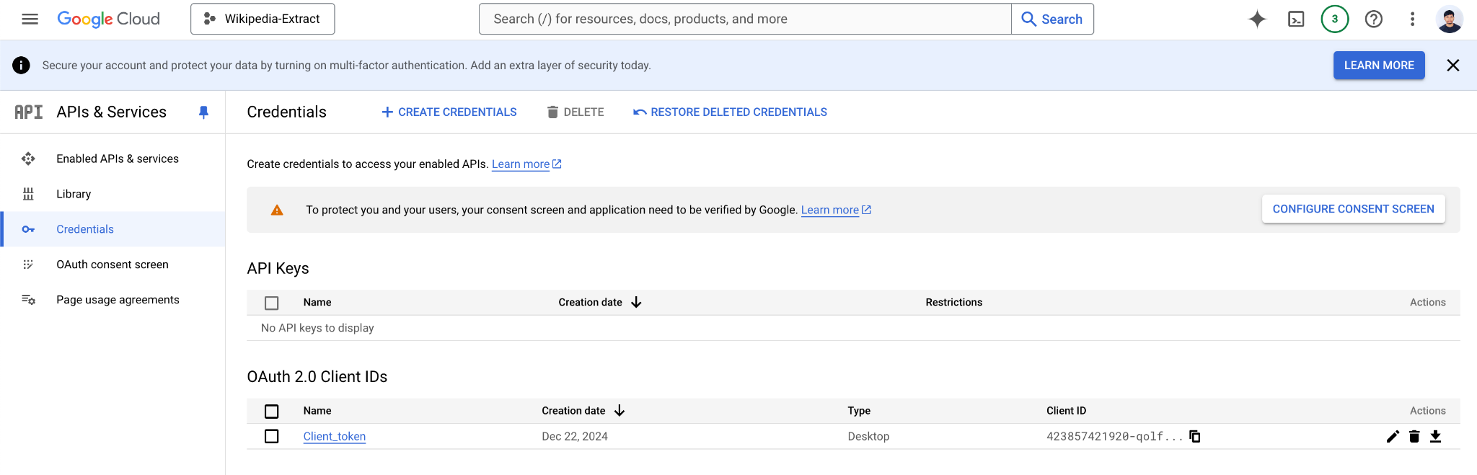

>> give service account name & grant the service account access to spreadsheet & google drive.

>> download authorization_key in Json file.